MASSCAN & RUSTSCAN – COMPREHENSIVE TECHNICAL DOCUMENTATION
High-Speed Network Port Scanning Tools for Ethical Hacking & Penetration Testing
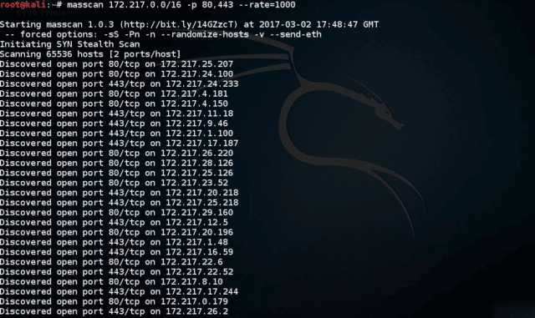
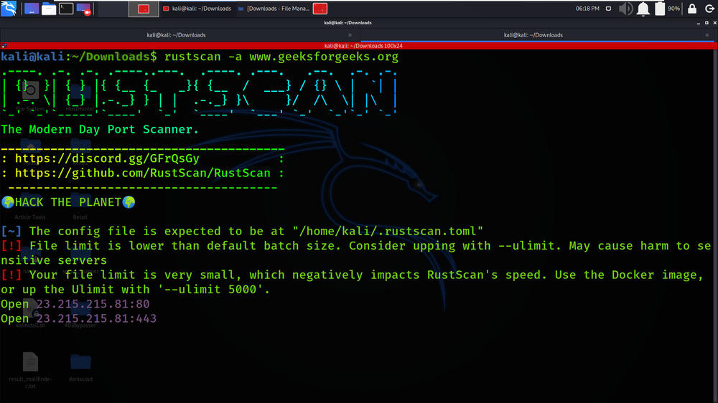
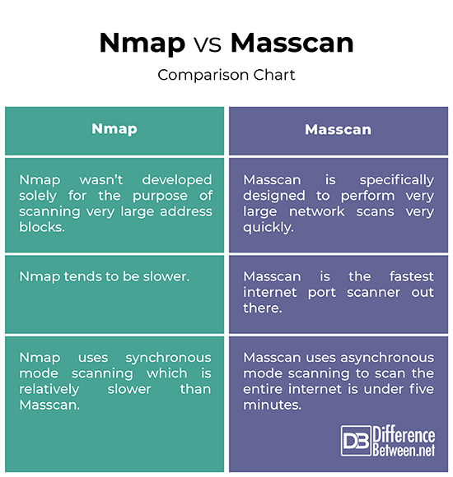
4

ABSTRACT
As modern networks grow larger and more complex, traditional port scanning techniques may become time-consuming and inefficient. To address this challenge, high-speed scanners such as Masscan and RustScan are used to rapidly identify open ports across large IP ranges. This document presents a comprehensive technical study of Masscan and RustScan, focusing on their internal working mechanisms, command usage, practical case studies, advantages, limitations, and defensive considerations. The objective is to provide an academic and practical understanding of these tools suitable for cybersecurity coursework, lab records, and professional penetration testing engagements.

PART A: MASSCAN TOOL
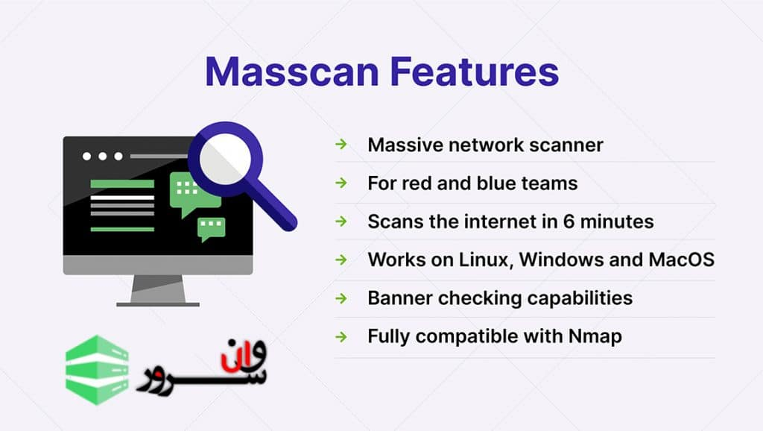
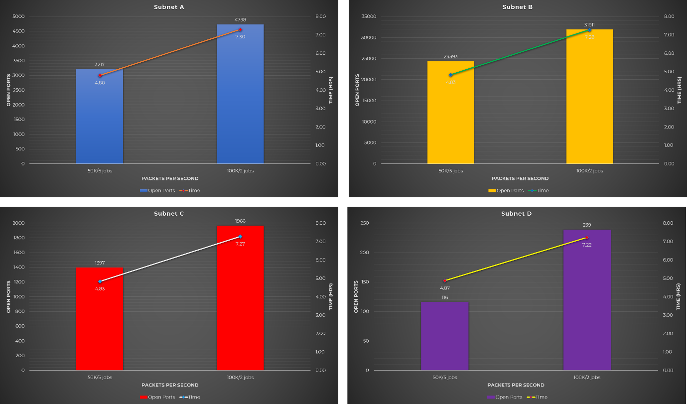
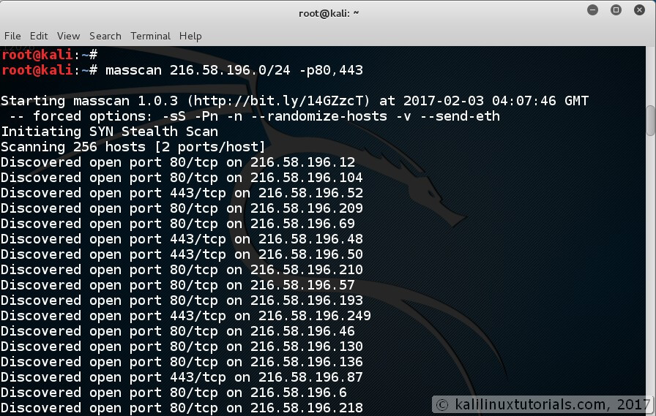

1. INTRODUCTION TO MASSCAN
Masscan is an ultra-fast network port scanner designed to scan the entire internet or large network ranges in a very short time. Unlike traditional scanners that prioritize accuracy and detail, Masscan prioritizes speed.
Masscan can scan millions of IP addresses per second, making it suitable for:
- Internet-wide research
- Large enterprise network assessments
- Rapid identification of exposed services
Because of its aggressive nature, Masscan must be used with extreme caution and proper authorization.

2. OBJECTIVE OF USING MASSCAN
The primary objectives of Masscan are:
- To perform extremely fast port scanning
- To identify open ports across large IP ranges
- To quickly reduce target scope for deeper analysis
- To support research and large-scale assessments
Masscan is typically used before Nmap to narrow down targets.

3. WORKING MECHANISM OF MASSCAN
Masscan uses asynchronous TCP SYN scanning. Instead of waiting for responses before sending new packets, it sends packets continuously and processes responses independently.
Key characteristics:
- Uses its own TCP/IP stack
- Sends SYN packets at very high rates
- Does not complete TCP handshakes
This design enables exceptional speed but limits detailed analysis.

4. INSTALLATION AND ENVIRONMENT
Masscan is pre-installed in Kali Linux.
To verify installation:
masscan --version
Root privileges are required because Masscan crafts raw packets.

5. COMMAND USAGE AND ANALYSIS (MASSCAN)
5.1 Basic Port Scan
masscan 192.168.1.0/24 -p80

5.2 Scan Multiple Ports
masscan 192.168.1.0/24 -p22,80,443

5.3 Scan All Ports
masscan 192.168.1.0/24 -p1-65535

5.4 Control Scan Rate
masscan 192.168.1.0/24 -p80 --rate 1000
Prevents network congestion.

5.5 Output to File
masscan 192.168.1.0/24 -p80 -oX masscan.xml

6. PRACTICAL CASE STUDY (MASSCAN)
Scenario
A tester needs to quickly identify exposed web services in a large network.
Execution
masscan 10.0.0.0/8 -p80,443 --rate 5000
Observations
- Multiple hosts with open web ports identified
- Scan completed in minutes instead of hours
Impact
Masscan drastically reduced scanning time and narrowed targets for detailed Nmap analysis.

7. ADVANTAGES & LIMITATIONS (MASSCAN)
Advantages
- Extremely fast
- Scales to very large networks
- Simple syntax
Limitations
- Very noisy
- Limited service detection
- High risk if misused

PART B: RUSTSCAN TOOL
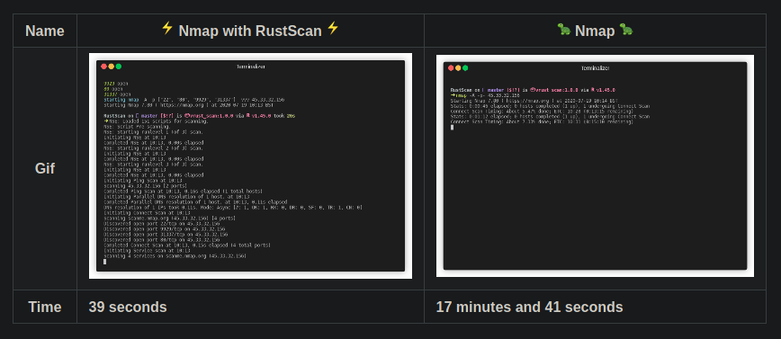
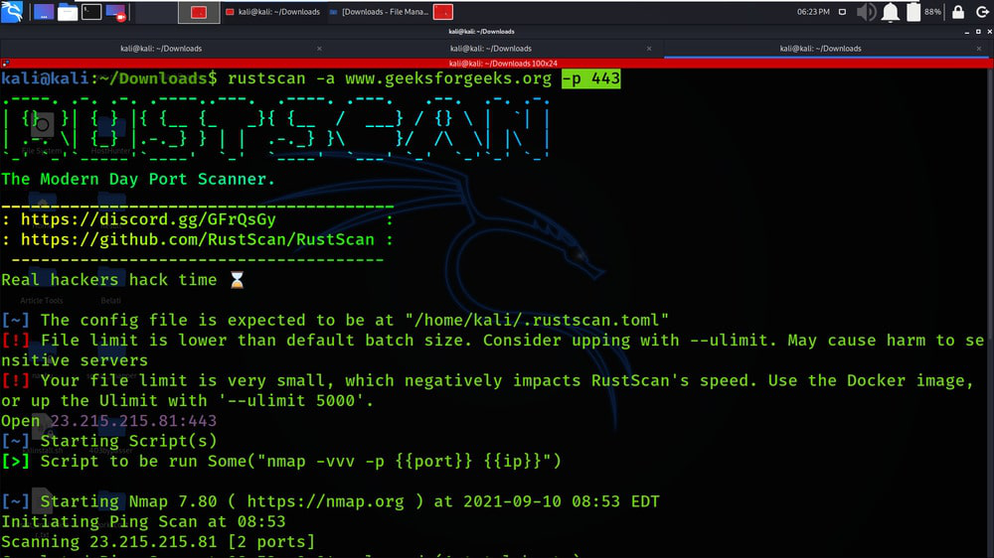
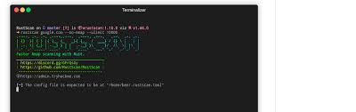

8. INTRODUCTION TO RUSTSCAN
RustScan is a modern, high-speed port scanner written in Rust, designed to combine the speed of Masscan with the accuracy and depth of Nmap.
Instead of replacing Nmap, RustScan acts as a front-end accelerator, quickly identifying open ports and automatically handing them off to Nmap for deeper scanning.

9. OBJECTIVE OF USING RUSTSCAN
The objectives of RustScan are:
- To perform fast port discovery
- To automate Nmap scanning
- To reduce manual effort
- To provide clean and actionable scan results
RustScan is ideal for CTFs, labs, and professional pentests.

10. WORKING MECHANISM OF RUSTSCAN
RustScan operates in two stages:
- Fast Port Discovery
Uses asynchronous scanning to identify open ports rapidly.
- Nmap Integration
Automatically launches Nmap with discovered ports for service and version detection.
This hybrid model balances speed and accuracy.

11. INSTALLATION AND ENVIRONMENT
RustScan is available in Kali Linux and as a standalone binary.
To verify installation:
rustscan --version
RustScan may require sudo privileges for certain scans.

12. COMMAND USAGE AND ANALYSIS (RUSTSCAN)
12.1 Basic Scan
rustscan -a 192.168.1.10

12.2 Scan with Port Range
rustscan -a 192.168.1.10 -r 1-65535

12.3 Automatic Nmap Scan
rustscan -a 192.168.1.10 -- -sV -sC

12.4 Limit Scan Speed
rustscan -a 192.168.1.10 --ulimit 5000

13. PRACTICAL CASE STUDY (RUSTSCAN)
Scenario
A tester performs reconnaissance on a CTF machine.
Execution
rustscan -a 192.168.146.131 -- -A
Observations
- Open ports detected within seconds
- Nmap automatically identified services and OS
Impact
RustScan significantly reduced setup time and improved workflow efficiency.

14. ADVANTAGES & LIMITATIONS (RUSTSCAN)
Advantages
- Very fast
- Seamless Nmap integration
- Modern and reliable
- Ideal for automation
Limitations
- Depends on Nmap for deep analysis
- Less configurable than raw Nmap

15. MASSCAN VS RUSTSCAN VS NMAP
Tool | Speed | Depth | Best Use Case
Masscan | Very High | Low | Large-scale discovery
RustScan | High | Medium–High | Fast pentesting
Nmap | Medium | Very High | Detailed analysis

16. SECURITY & DEFENSIVE CONSIDERATIONS
Organizations should:
- Monitor high-rate scanning traffic
- Use IDS/IPS and rate limiting
- Block unauthorized scanning
- Regularly audit exposed services

17. LEGAL & ETHICAL CONSIDERATIONS
Masscan and RustScan must only be used with explicit authorization. Due to their speed, misuse can lead to legal consequences and service disruption.

18. CONCLUSION
Masscan and RustScan represent the evolution of network scanning toward speed and automation. While Masscan excels in large-scale discovery, RustScan bridges the gap between speed and detailed analysis by integrating Nmap. Mastery of these tools equips cybersecurity students and professionals with efficient and modern scanning capabilities.

19. REFERENCES
- Kali Linux Documentation
- Masscan Official Documentation
- RustScan GitHub Repository
- OWASP Scanning Guide

